Bethon Worker’s companion app & web page

Table of contents:
Introduction …………………………………………………………………………………. 2
Definition ………………………………………………………………………………………… 3
Planning …………………………………………………………………………………………… 3 - 4
Implementation ……………………………………….……………………………………… 4
Implementation phase ……………………………………………………………………. 4 - 5
Implementation phase 2 …………………………………………………………………. 5 - 6
Implementation phase 3 ………………………………………………………………... 6
Testing ……………………………………………………………………………………………… 7
Presentation of the project ……………………………………………………………… 8
Final report and conclusions ……………………………………………………………. 8 - 9

Introduction:

The app and website are going to be created as a customer request for workers work hour loggings should be easy access easy to use, and mostly automated.
As the companion website has been created, with admin website included, and registering for new employees, both on admin dashboard, and on the main site.
The application will be worked out with python Kivy framework for android.
All the programs and features, and necessary installations are listed within the document: “System requirement and install guide.md”.
I personally from the team (Janos) aim to create a better companion app for the employees than of “Eepee”, uses. Since I always hear my partner’s complaints about the service. Hence the reason is now my team does something different than games. (And of course the customer had given us 4 options including a game.)

Definition

The companion website connected to the server” db” uses python as programming language. The Server set up uses MariaDB. Used IDE: PyCharm
Used libraries within the Python
- pip install mariadb
- pip install flask
- pip install mysql
- pip install mysql-connector-python
Used Windows “CMD”-line as admin and as user to connect to the server and launch the app.py for the website.

For the companion app: We decided to use Android Studio, with Kotlin programing language.

Planning
Team member Janos wanted to ensure that there is a user interface for the server database. For that the best option seems to be if the team creates a web-based solution. (At this point the website is up, but it has some features that need some tweaking here is the reason):
Upon accidental reveal, it does not matter if the Database (db) server has shut down, the timer still ticking while the employee is signed in, on a test run I (Janos) ended up with almost 22h of work hour logged into the “db” server.
And so, we plan the application Janos have a clear vision for security measurements and for ease-of-use features. Time will tell:
Possible features:
- QR code generating and hardcoding them to location, ensuring within the companion app the users don’t need to manually log in to start logging in during work hours, and the location to get data for being actually at the working place (inside the company who uses the app)
- The companion app sends an alert when the shift is exceeding 8 hours and 10 minutes to the user’s phone, for overtime confirmation, otherwise the app will automatically log the user out if not confirmed within 1 minute. (Team approved).
- Maybe for friendly notifications the app could be said out loud
- “Welcome again “name”, have a nice shift” (when signing in)
- “Have a good rest for the rest of the day” (when signing out)
- “Alert your shift exceeded 8 hours please confirm overtime or sign out” (exceeding shift time)
The third part can be Finnish as well.

Implementation phase 1

The website is up and running done by Janos. Refer to “Project update.pptx” or “Project update.odp” which ever is accessible at the time. 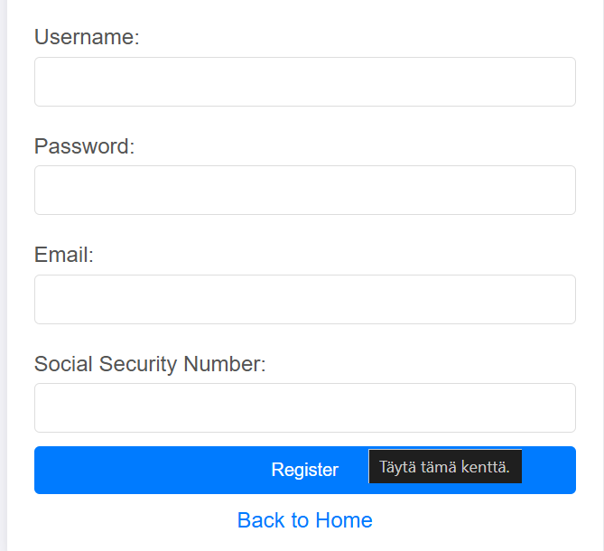
The image shown above is the last part of the registration.
Currently the web-based side has some needs on updated features, like the auto log out after 8 hours and 15 minutes, and have the need also for implementing the logic for the notifier for the companion application. May need some refinement on the time and date handling at the profile logs. Also needs improvement on the login/ logout logs handling within the administrator dashboard. 2024.11.29

